A banking scenario

Each BANK has a unique Code, as well as a Name and Address. Each BANK is related to one or more BANK-BRANCHes, and the BranhNo is unique among each set of BANK-BRANCHes that are related to the same BANK. Each BANK-BRANCH has an Address and Branch Name. Each BANK-BRANCH has zero or more LOANS and zero or more ACCTS. Each ACCOUNT has an AcctNo (unique), Balance, and Type and is related to exactly one BANK-BRANCH and to at least one CUSTOMER. Each LOAN has a LoanNo (unique), Amount, and Type and is related to exactly one BANK-BRANCH and to at least one CUSTOMER. Each CUSTOMER has an SSN (unique), Name, Phone, and Address, and is related to zero or more ACCOUNTs and to zero or more LOANs. Create an ER diagram for a database to represent this application.

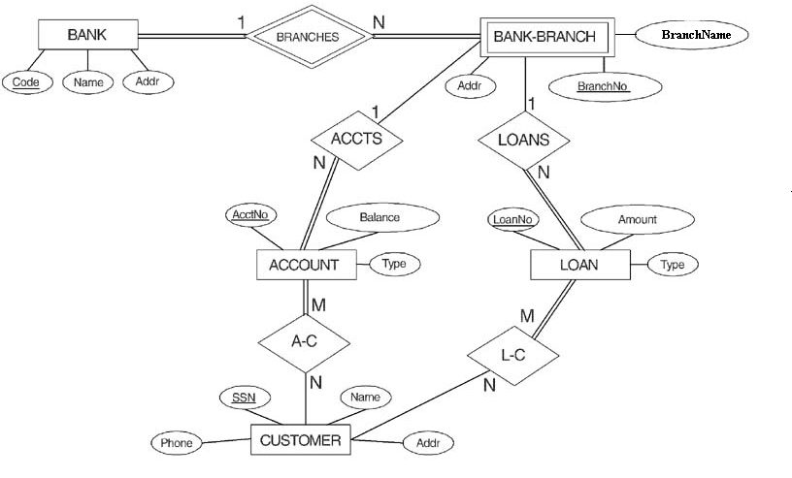

Designing an ER Diagram

Consider the following set of requirements for a University database. Design an ER diagram for this application:

* The university keeps track of each student's name, student number, social security number, current address and phone number, permanent address and phone number, birthdate, sex, class (freshman, graduate), major department, minor department (if any), degree program (B.A., B.S., ... Ph.D.).  Some user applications need to refer to the city, state, and zip code of the student's permanent address and to the student's last name.  Both social security number and student number are unique for each student. All students will have at least a major department.
* Each department is described by a name, department code, office number, office phone, and college.  Both the name and code have unique values for each department.
* Each course has a course name, description, course number, number of credits, level and offering department.  The course number is unique for each course.
* Each section has an instructor, semester, year, course, and section number.  The section number distinguishes sections of the same course that are taught during the same semester/year; its value is an integer (1, 2, 3, ... up to the number of sections taught during each semester).
* A grade report must be generated for each student that lists the section, letter grade, and numeric grade (0,1,2,3, or 4) for each student and calculates his or her average GPA.

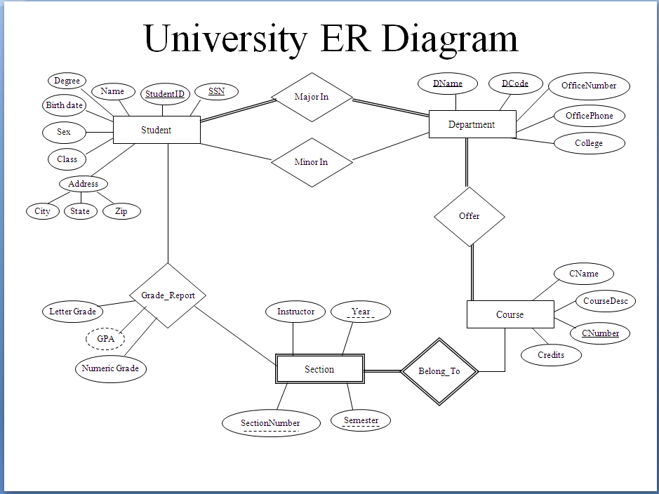

Consider a hospital:

Patients are treated in a single ward by the doctors assigned to them. Usually each patient will be assigned a single doctor, but in rare cases they will have two.

Heathcare assistants also attend to the patients, a number of these are associated with each ward.

Initially the system will be concerned solely with drug treatment. Each patient is required to take a variety of drugs a certain number of times per day and for varying lengths of time.

The system must record details concerning patient treatment and staff payment. Some staff are paid part time and doctors and care assistants work varying amounts of overtime at varying rates (subject to grade).

The system will also need to track what treatments are required for which patients and when and it should be capable of calculating the cost of treatment per week for each patient (though it is currently unclear to what use this information will be put).

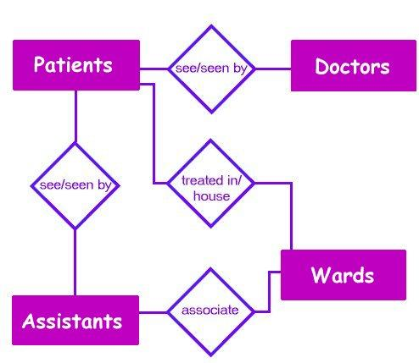

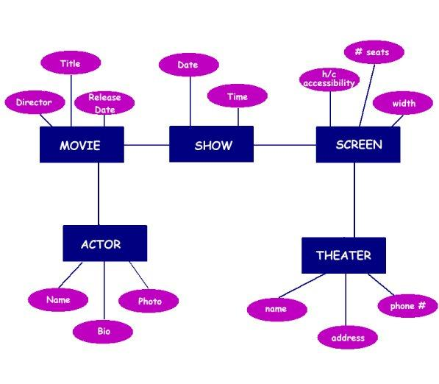

CHAPTER 3: DATA MODELING USING THE ENTITY-RELATIONSHIP MODEL

Answers to Selected Exercises

3.16 Consider the following set of requirements for a university database that is used to

keep track of students' transcripts. This is similar but not identical to the

database shown in Figure 1.2:

(a) The university keeps track of each student's name, student number, social

security number, current address and phone, permanent address and phone,

birthdate, sex, class (freshman, sophomore, ..., graduate), major department,

minor department (if any), and degree program (B.A., B.S., ..., Ph.D.). Some user

applications need to refer to the city, state, and zip of the student's permanent

address, and to the student's last name. Both social security number and student

number have unique values for each student.

(b) Each department is described by a name, department code, office number, office

phone, and college. Both name and code have unique values for each department.

(c) Each course has a course name, description, course number, number of semester

hours, level, and offering department. The value of course number is unique for

each course.

(d) Each section has an instructor, semester, year, course, and section number. The

section number distinguishes different sections of the same course that are taught

during the same semester/year; its values are 1, 2, 3, ...; up to the number of

sections taught during each semester.

(e) A grade report has a student, section, letter grade, and numeric grade (0, 1, 2, 3,

4 for F, D, C, B, A, respectively).

Design an ER schema for this application, and draw an ER diagram for that schema.

Specify key attributes of each entity type and structural constraints on each relationship type. Note any unspecified requirements, and make appropriate assumptions to make the specification complete.

Answer:

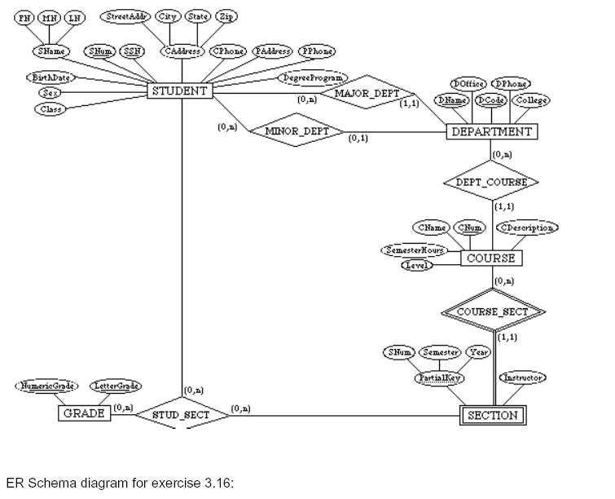

3.17 Composite and multi-valued attributes can be nested to any number of levels.

Suppose we want to design an attribute for a STUDENT entity type to keep track of

previous college education. Such an attribute will have one entry for each college

previously attended, and this entry is composed of: college name, start and end

dates, degree entries (degrees awarded at that college, if any), and transcript

entries (courses completed at that college, if any). Each degree entry is formed of

degree name and the month and year it was awarded, and each transcript entry is

formed of a course name, semester, year, and grade. Design an attribute to hold

this information. Use the conventions of Figure 3.5.

Answer:

{ PreviousEducation ( CollegeName, StartDate, EndDate,

{ Degree (DegreeName, Month, Year) },

{ Transcript (CourseName, Semester, Year, Grade) } ) }

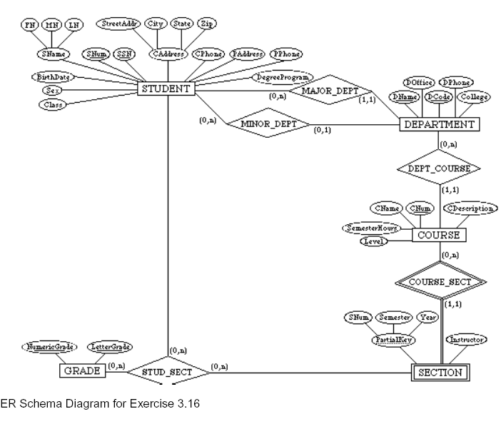

3.18 Show an alternative design for the attribute described in Exercise 3.17 that uses

only entity types (including weak entity types if needed) and relationship types.

Answer:

This example illustrates a perceived weakness of the ER model, which is: how does the

database designer decide what to model as an entity type and what to model as a

relationship type. In our solution, we created a weak entity type ATTENDANCE; each

(weak) entity in ATTENDANCE represents a period in which a STUDENT attended a

particular COLLEGE, and is identified by the STUDENT and the StartDate of the period.

Hence, the StartDate attribute is the partial key of ATTENDANCE. Each ATTENDANCE

entity is related to one COLLEGE and zero or more DEGREEs (the degrees awarded during

that attendance period). The TRANSCRIPT of the STUDENT during each attendance period

is modeled as a weak entity type, which gives the records of the student during the

attendance period. Each (weak) entity in TRANSCRIPT gives the record of the sudent in

one course during the attendance period, as shown in the ER diagram below. Other ER

schema designs are also possible for this problem.

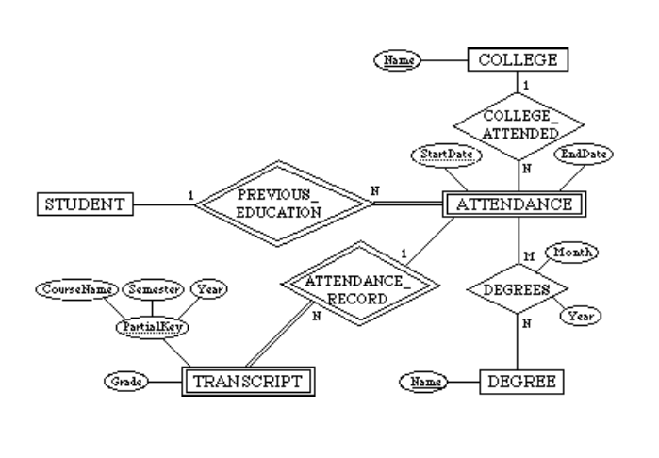

3.19 Consider the ER diagram of Figure 3.17, which shows a simplified schema for an

airline reservations system. Extract from the ER diagram the requirements and

constraints that resulted in this schema. Try to be as precise as possible in your

requirements and constraints specification.

Answer:

(1) The database represents each AIRPORT, keeping its unique AirportCode, the

AIRPORT Name, and the City and State in which the AIRPORT is located.

(2) Each airline FLIGHT has a unique number, the Airline for the FLIGHT, and the

Weekdays on which the FLIGHT is scheduled (for example, every day of the week

except Sunday can be coded as X7).

(3) A FLIGHT is composed of one or more FLIGHT LEGs (for example, flight number

CO1223 from New York to Los Angeles may have two FLIGHT LEGs: leg 1 from New

York to Houston and leg 2 from Houston to Los Angeles). Each FLIGHT LEG has a

DEPARTURE AIRPORT and Scheduled Departure Time, and an ARRIVAL AIRPORT and

Scheduled Arrival Time.

(4) A LEG INSTANCE is an instance of a FLIGHT LEG on a specific Date (for example,

CO1223 leg 1 on July 30, 1989). The actual Departure and Arrival AIRPORTs and

Times are recorded for each flight leg after the flight leg has been concluded. The

Number of available seats and the AIRPLANE used in the LEG INSTANCE are also

kept.

(5) The customer RESERVATIONs on each LEG INSTANCE include the Customer Name,

Phone, and Seat Number(s) for each reservation.

(6) Information on AIRPLANEs and AIRPLANE TYPEs are also kept. For each AIRPLANE

TYPE (for example, DC-10), the TypeName, manufacturing Company, and

Maximum Number of Seats are kept. The AIRPORTs in which planes of this type

CAN LAND are kept in the database. For each AIRPLANE, the AirplaneId, Total

number of seats, and TYPE are kept.

3.20 No solution provided

3.21.

Additional information:

- There are 435 congresspersons in the U.S. House of Representatives.

- States have between one (AK, DE, MT, ND, SD, VT, and WY) and 52 (CA)

representatives.

- M represents number of bills during the 2-year session.

The resulting ER Diagram is shown in Figure A.

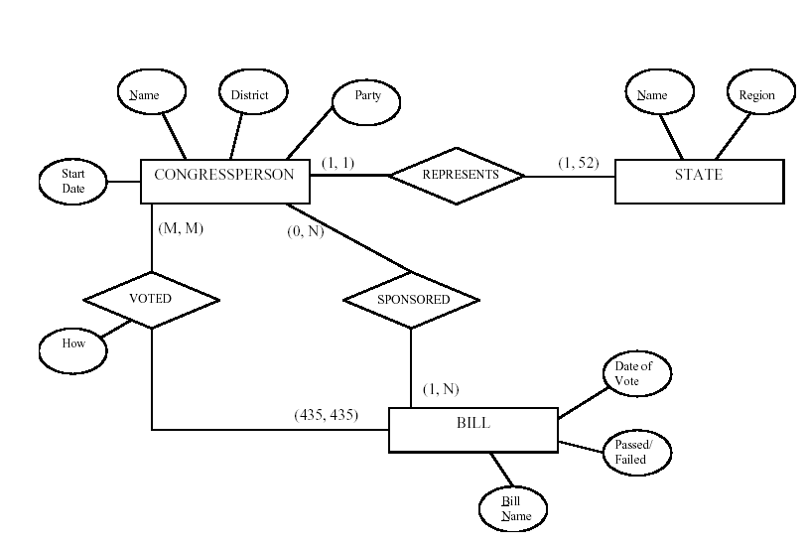

3.22 A database is being constructed to keep track of the teams and games of a sports

league. A team has a number of players, not all of whom participate in each game.

It is desired to keep track of the players participating in each game for each team,

the positions they played in that game, and the result of the game. Try to design an

ER schema diagram for this application, stating any assumptions you make.

Choose your favorite sport (soccer, football, baseball, ...).

Answer:

The following design may be used for a baseball league. Here, we assumed that each game

in the schedule is identified by a unique Game#, and a game is also identified uniquely by

the combination of Date, starting Time, and Field where it is played. The Performance

attribute of PARTICIPATE is used to store information on the individual performance of

each player in a game. This attribute can be designed to keep the information needed for

statistics, and may be quite complex. One possible design for the Performance attribute

may be the following (using the notation of Figure 3.8):

Performance( {Hitting(AtBat#, Inning#, HitType, Runs, RunsBattedIn, StolenBases)},

{Pitching(Inning#, Hits, Runs, EarnedRuns, StrikeOuts, Walks, Outs,

Balks, WildPitches)},

{Defense(Inning#, {FieldingRecord(Position, PutOuts, Assists, Errors)})} )

Here, performance is a composite attribute made up of three multivalued components:

Hitting, Pitching, and Defense. Hitting has a value for each AtBat of a player, and records

the HitType (suitable coded; for example, 1 for single, 2 for double, 3 for triple, 4 for

home run, 0 for walk, -1 for strikeout, -2 for fly out, ...) and other information

concerning the AtBat. Pitching has a value for each inning during which the player

pitched. Defense has a value for each inning a player played a fielding position. We can

have a less detailed or a more detailed design for the performance of a player in each

game, depending on how much information we need to keep in the database. Suitable

variations of the ER diagram shown below can be used for other sports.

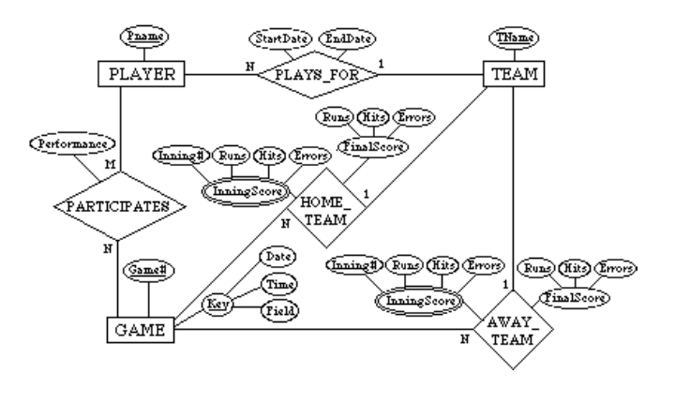

3.23 Consider the ER diagram shown in Figure 3.18 for part of a BANK database. Each

bank can have multiple branches, and each branch can have multiple accounts and

loans.

(a) List the (nonweak) entity types in the ER diagram.

(b) Is there a weak entity type? If so, give its name, its partial key, and its

identifying relationship.

(c) What constraints do the partial key and the identifying relationship of the

weak entity type specify in this diagram?

(d) List the names of all relationship types, and specify the (min,max) constraint

on each participation of an entity type in a relationship type. Justify your

choices.

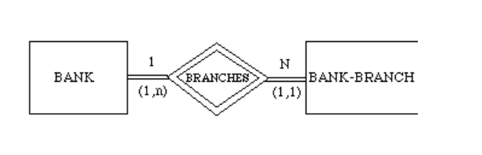

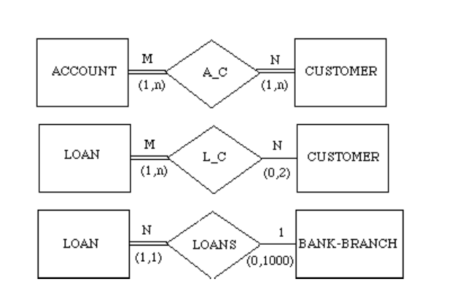

(e) List concisely the user requirements that led to this ER schema design.

(f) Suppose that every customer must have at least one account but is restricted

to at most two loans at a time, and that a bank branch cannot have more than

1000 loans. How does this show up on the (min,max) constraints?

Answer:

(a) Entity types: BANK, ACCOUNT, CUSTOMER, LOAN

(b) Weak entity type: BANK-BRANCH. Partial key: BranchNo.

Identifying relationship: BRANCHES.

(c) The partial key BranchNo in BANK-BRANCH specifies that the same BranchNo value

may occur under different BANKs. The identifying relationship BRANCHES specifies that

BranchNo values are uniquely assigned for those BANK-BRANCH entities that are related

to the same BANK entity. Hence, the combination of BANK Code and BranchNo together

constitute a full identifier for a BANK-BRANCH.

(d) Relationship Types: BRANCHES, ACCTS, LOANS, A-C, L-C. The (min, max) constraints

are shown below.

(e) The requirements may be stated as follows: Each BANK has a unique Code, as well as a

Name and Address. Each BANK is related to one or more BANK-BRANCHes, and the

BranhNo is unique among each set of BANK-BRANCHes that are related to the same BANK.

Each BANK-BRANCH has an Address. Each BANK-BRANCH has zero or more LOANS and

zero or more ACCTS. Each ACCOUNT has an AcctNo (unique), Balance, and Type and is

related to exactly one BANK-BRANCH and to at least one CUSTOMER. Each LOAN has a

LoanNo (unique), Amount, and Type and is related to exactly one BANK-BRANCH and to at

least one CUSTOMER. Each CUSTOMER has an SSN (unique), Name, Phone, and

Address, and is related to zero or more ACCOUNTs and to zero or more LOANs.

(f) The (min, max) constraints would be changed as follows:

3.24 Consider the ER diagram in Figure 3.19. Assume that an employee may work in up to two departments or may not be assigned o any department. Assume that each department must have one and may have up to three phone numbers. Supply (min, max) constraints on this diagram. State clearly any additional assumptions you make. Under what conditions would the relationship HAS_PHONE be redundant in this example?

Answer:

Assuming the following additional assumptions:

- Each department can have anywhere between 1 and 10 employees.

- Each phone is used by one, and only one, department.

- Each phone is assigned to at least one, and may be assigned to up to 10 employees.

- Each employee is assigned at least one, but no more than 6 phones.

The resulting ER Diagram will have the (min, max) constraints shown in Figure A.

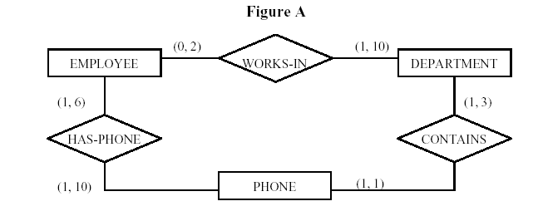

Relationship HAS-PHONE would be redundant under the following conditions:

- Each employee is assigned all of the phones of each department that he/she works in.

- An employee cannot have any other phones outside the departments he/she works is.

EMPLOYEE

PHONE

DEPARTMENT

HAS-PHONE CONTAINS

WORKS-IN

(0, 2)

(1, 3)

(1, 10)

(1, 10) (1, 1)

(1, 6)

3.25. Consider the ER diagram in Figure 3.20. Assume that a course may or may not use a textbook, but that a text by definition is a book that is used in some course. A course may not use more than five books. Instructors teach from two to four courses. Supply (min, max) constraints on this diagram. State clearly any additional assumptions you make. If we add the relationship ADOPTS between INSTRUCTOR and TEXT, what (min, max) constraints would you put on it? Why?

Answer:

Assuming the following additional assumptions:

- Each course is taught by exactly one instructor.

- Each textbook is used by one and only one course.

- An instructor does not have to adopt a textbook for all courses.

- If a text exists:

- ___it is used in some course,

- ___hence it is adopted by some instructor who teaches that course.

- An instructor is considered to adopt a text if it is used in some course taught

- by that instructor.

The resulting ER Diagram will have the (min, max) constraints shown in Figure B.

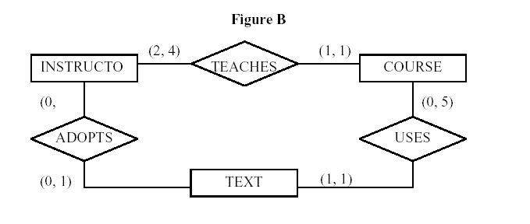

3.26 Consider an entity type SECTION in a UNIVERSITY database, which describes the section offerings of courses. The attributes of SECTION are SectionNumber, Semester, Year, CourseNumber, Instructor, RoomNo (where section is taught), Building (where section is taught), Weekdays (domain is the possible combinations of weekdays in which a section can be offered {MWF, MW, TT, etc.}). Assume tat SectionNumber is unique for each course within a particular semester/year combination (that is, if a course if offered multiple times during a particular semester, its section offerings are numbered 1, 2, 3, etc.). There are several composite keys for SECTION, and some attribute sare components of more than one key. Identify three composite keys, and show how they can be represented in an ER schema diagram.

Answer:

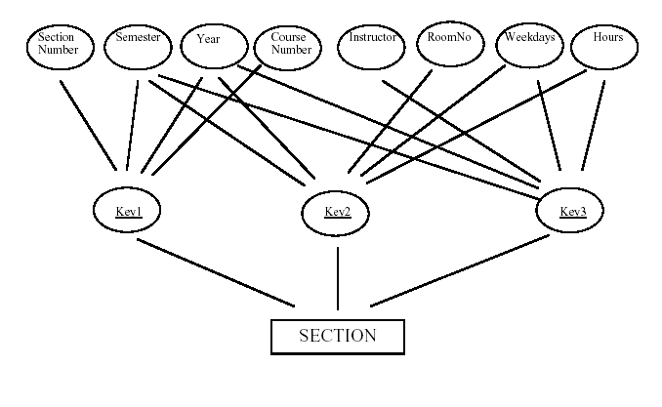

1. Consider the ER diagram below. Extract the requirements and constraints that produced this schema. Make your specifications as precise as possible.

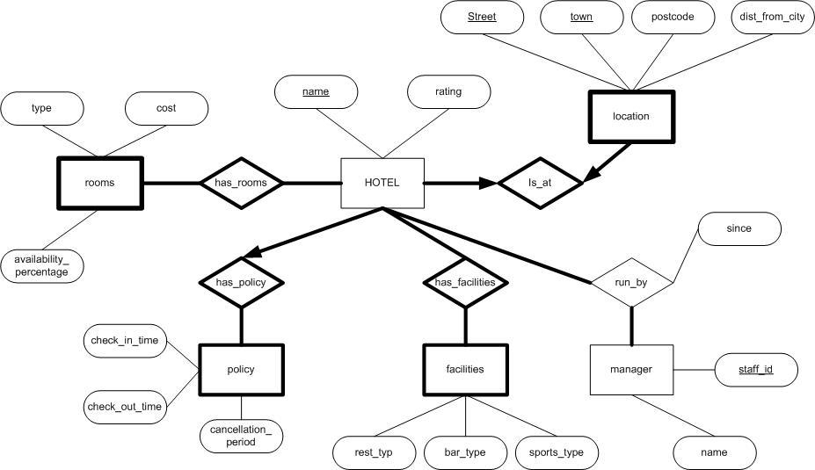

1. Consider the ER diagram below. Extract the requirements and constraints that produced this schema. Make your specifications as precise as possible.

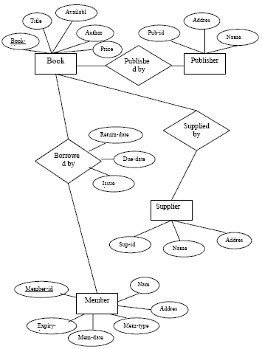

page revision: 1, last edited: 14 Dec 2009, 19:08 GMT+0530 (989 days ago)

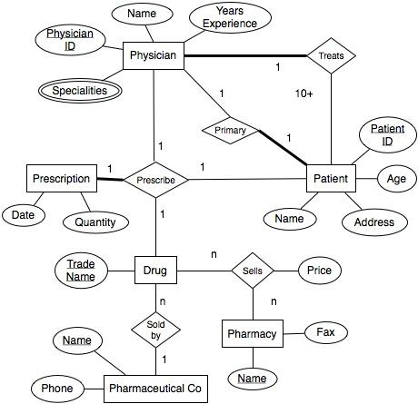

Pharmacy Database